25.1 Editors - Properties Editor - Tools Tab
Tools Tab - General 2
Tool settings area 2
Workspace panel 2
Mode 2
Filter Addons 3
Custom Properties 3
Mode specific panels 3
Tools Tab and Top Bar 4

Tools Tab - General

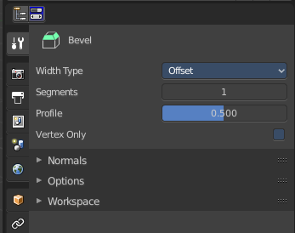
The Tools tab contains the tools settings for the currently active tool in the 3D view or in one of the image editors. The editor types that have a topbar.
UV Editing layout is one case where both editor types are open side by side. And what gets displayed depends which tool you have activated last in which editor.
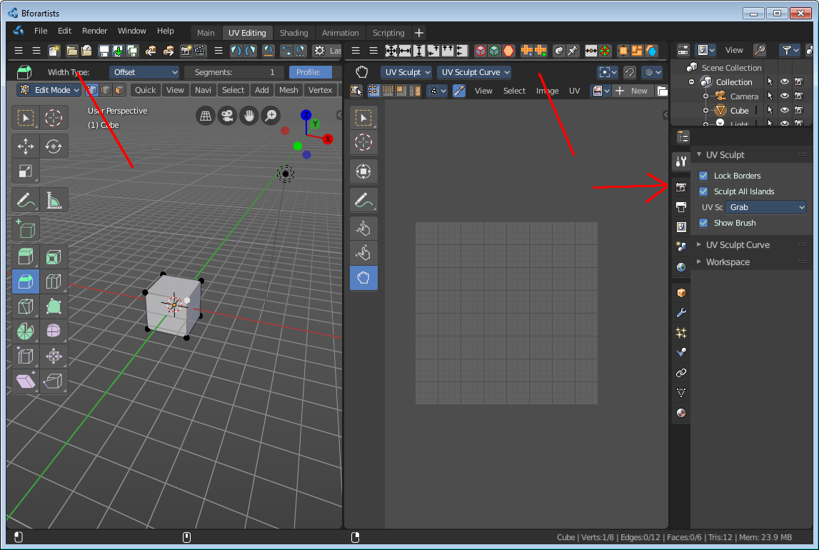
For example when you have the Knife tool in edit mode in the 3D View selected, then you will find its tool settings here. Or when you are in Vertex Paint, then you will find the paint tools here.
When you now activate one of the tools in the UV Editor, the grab tool for example, then the tool settings for this tool from the UV editor will be displayed.
The content is also mode dependant. When you are in Edit mode with a mesh object, then you will have the Mesh options and the Normal Tools panels.
Something that is available in all modes is the Workspace panel.
The tool specific settings above the panels, in this case the Surface Project check box an dthe Orientation Dropdown box will be explained in the manual parts where this tools are covered. In the Tool shelf chapters.

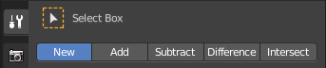
Tool settings area
In this area you will find all the tool relevant settings for the currently active tool. The tool specific settings.
Every tool has other specific settings here. The select tools has a row of buttons where you can choose if you want to start a new selection, add to the current selection and so on.
Tool specific settings are covered where they happen. Means either in the tool shelf chapters of the editors. Or in the menu chapters of he editors.
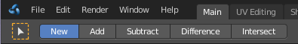
The display starts with the select tools by default.

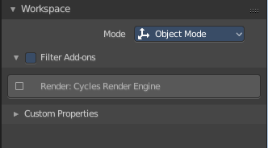
Workspace panel
Workspaces can be configured to start in specific modes, and with a specific sets of active addons. This is the place where you configure this settings.
You have to save the startup file to make these changes permanent.

Mode
The mode in which the 3D view should start when you switch to this workspace layout.

Filter Addons
Here you can filter, means activate or deactivate specific addons.

Custom Properties
Custom properties allows you to store your own metadata. This metadata cna then be used for rigging and Python scripts.
The following data supports custom properties:
- All data-blocks types.
- Bones and Pose-Bones.
- Sequence strips.

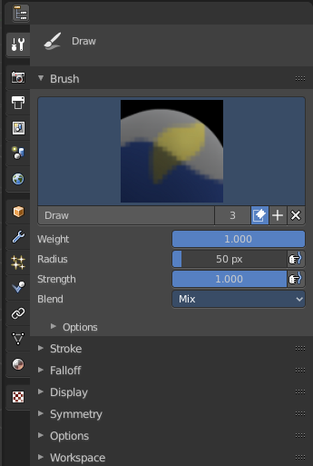
Mode specific panels
In Object mode you don't have any panels in the tools tab besides the Workspace panel and the current tool settings. In all other modes you have specific panels that contains options and the tools settings.
In Weightpaint mode you have for example all brush related panels.
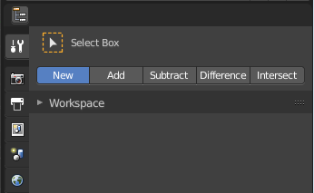

Tools Tab and Top Bar

The content of the tools tab is identical to the content of the Top Bar. It's the same tool set. You can decide by yourself with which set you want to work. The Top bar can be hidden if you don't need it.

What is missing in the Top Bar is the Workspace settings.

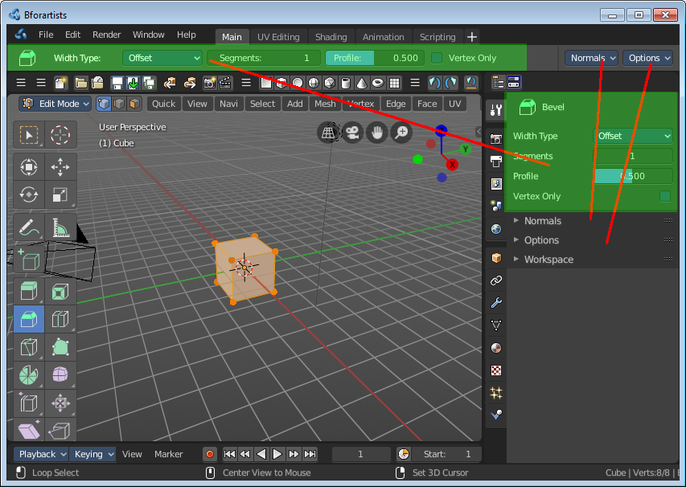
This means that the documentation for the tools tab is also the documentation of the Top Bar.

